Full House: A Hoarder’s Journey

Most of us have a lot of stuff and some of us hang on to things that others put on the curb or leave at the dump. Our closets are full, flat surfaces are a magnet for all kinds of items, and there are stacks of newspapers and magazines in every corner. It is a struggle for us to find things amid the chaos in our homes.

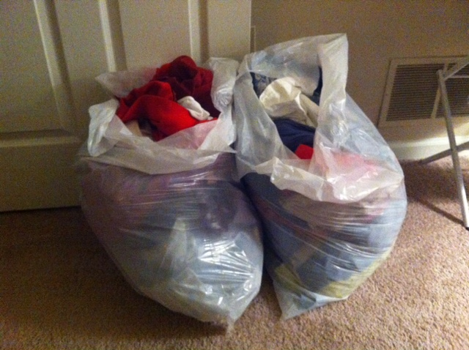

Join us at the Marlborough Public Library
35 West Main Street Marlborough – Bigelow Auditorium

Thursday Oct. 6th at 6 pm

Lorraine Gilmore, who has the disorder known as compulsive hoarding, will share her journey to downsize. She will share her struggle and which strategies helped.



